SQL
      - Introduction to SQL-What Is SQL & Database
      - Data Types, Primary-Foreign Keys & Constraints
        - Install postgresql and pgadmin4
      - Create Table In SQL & Create Database
      - INSERT UPDATE, DELETE & ALTER Table
      - SELECT Statement & WHERE Clause with Example
      - How To Import Excel File (CSV) to SQL
      - Functions in SQL & String Function
      - Aggregate Functions – Types & Syntax
      - Group By and Having Clause
      - Time Stamp and Extract Function, Date Time Function
      - SQL JOINS – Types & Syntax
      - SELF JOIN, UNION & UNION ALL
      - Subquery

- Window Function – Types & Syntax
- Case Statement/Expression with examples
- CTE- Common Table Expression with examples


Relational Database | Non-Relational Database
SQL database | NoSQL database
Data stored in tables | Data stored are either key-value pairs, document-based, graph databases or wide- column stores
These databases have fixed or static or predefined schema | They have dynamic schema
Low performance with huge volumes of data | Easily work with huge volumes of data
Eg: PostgreSQL, MySQL, MS SQL Server | Eg: MongoDB, Cassandra, Hbase

7


There are mainly 3 types of SQL commands:
- DDL (Data Definition Language): create, alter, and drop
- DML (Data Manipulation Language): select, insert, update and delete
- DCL (Data Control Language): grant and revoke permission to users

8





Database is a system that allow users to store and organise data

9



Excel | Database
Easy to use- untrained person can work | Trained person can work
Data stored less data | Stores large amount of data
Good for one time analysis, quick charts | Can automate tasks
No data integrity due to manual operation | High data integrity
Low search/filter capabilities | High search/filter capabilities

10


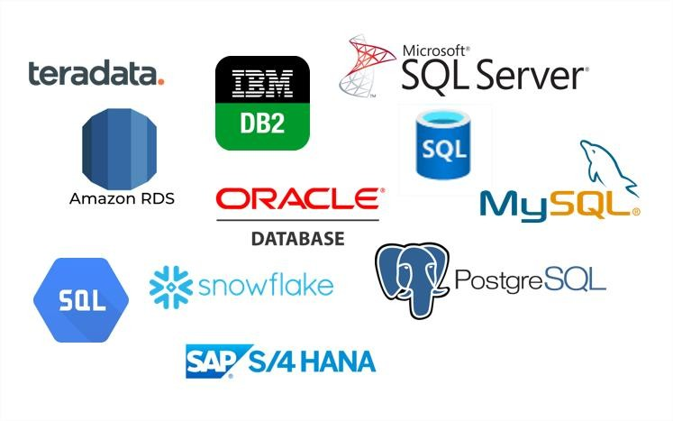

11



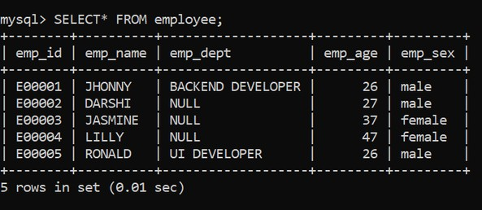
Database
Tables
Data

(Rows & Columns)
Columns
Example
Rows
RDBMS

13


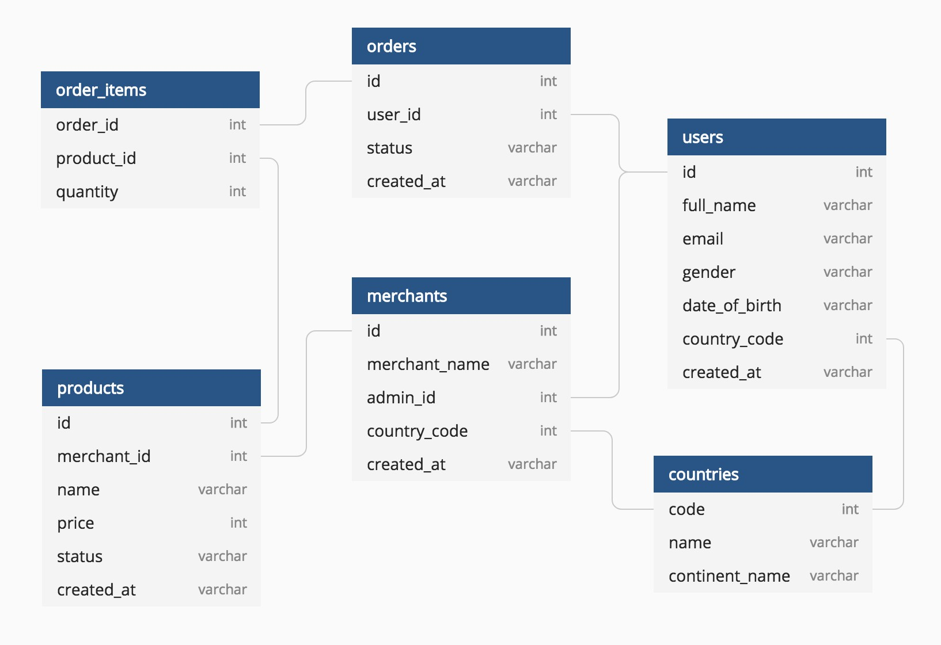
Example
14

•
•
•
•
•
•
•
•
•
•
•

15



- Data type of a column defines what value the column can store in table
- Defined while creating tables in database

Data types mainly classified into three categories + most used

oString: char, varchar, etc oNumeric: int, float, bool, etc oDate and time: date, datetime, etc
16



- int: used for the integer value
- float: used to specify a decimal point number
- bool: used to specify Boolean values true and false
- char: fixed length string that can contain numbers, letters, and special characters
- varchar: variable length string that can contain numbers, letters, and special characters
- date: date format YYYY-MM-DD
- datetime: date & time combination, format is YYYY-MM-DD hh:mm:ss

17




- A Primary key is a unique column we set in a table to easily identify and locate data in queries
- A table can have only one primary key, which should be unique and NOT NULL

- A Foreign key is a column used to link two or more tables together
- A table can have any number of foreign keys, can contain duplicate and NULL values
18


- Constraints are used to specify rules for data in a table
- This ensures the accuracy and reliability of the data in the table
- Constraints can be specified when the table is created with the CREATE TABLE statement, or
- after the table is created with the ALTER TABLE statement
- Syntax
CREATE TABLE table_name ( column1 datatype constraint, column2 datatype constraint, column3 datatype constraint,
....
);

19


- NOT NULL - Ensures that a column cannot have a NULL value
- UNIQUE - Ensures that all values in a column are different
- PRIMARY KEY - A combination of a NOT NULL and UNIQUE
- FOREIGN KEY - Prevents actions that would destroy links between tables (used to link multiple tables together)
- CHECK - Ensures that the values in a column satisfies a specific condition
- DEFAULT - Sets a default value for a column if no value is specified
- CREATE INDEX - Used to create and retrieve data from the database very quickly
20


The CREATE TABLE statement is used to create a new table in a database
- Syntax
CREATE TABLE table_name
(
column_name1 datatype constraint,
column_name2 datatype constraint, column_name3 datatype constraint,
);

- Example
CREATE TABLE customer
(
CustID int8 PRIMARY KEY,
CustName varchar(50) NOT NULL, Age int NOT NULL,
City char(50), Salary numeric
);
23



The INSERT INTO statement is used to insert new records in a table
- Syntax
INSERT INTO TABLE_NAME
(column1, column2, column3,...columnN) VALUES
(value1, value2, value3,...valueN);
- Example
INSERT INTO customer
(CustID, CustName, Age, City, Salary)
VALUES
(1, ‘Sam’, 26, ‘Delhi’, 9000),
(2, ‘Ram’, 19, ‘Bangalore’, 11000),
(3, ‘Pam’, 31, ‘Mumbai’, 6000),
(4, ‘Jam’, 42, ‘Pune’, 10000);
25



The UPDATE command is used to update existing rows in a table
- Syntax
UPDATE TABLE_NAME
SET “Column_name1” = ‘value1’, “Column_name2” = ‘value2’ WHERE “ID” = ‘value’

Example
UPDATE customer
SET CustName = 'Xam’, Age= 32
WHERE CustID = 4;

26



The ALTER TABLE statement is used to add, delete, or modify columns in an existing table
- ALTER TABLE - ADD Column Syntax
ALTER TABLE table_name
ADD COLUMN column_name ;

ALTER TABLE - DROP COLUMN Syntax
ALTER TABLE table_name
DROP COLUMN column_name;

ALTER TABLE - ALTER/MODIFY COLUMN Syntax
ALTER TABLE table_name
ALTER COLUMN column_name datatype;
27



The DELETE statement is used to delete existing records in a table
- Syntax
DELETE FROM table_name WHERE condition;

Example
DELETE FROM customer WHERE CustID = 3;

28



The DROP TABLE command deletes a table in the database
- Syntax
DROP TABLE table_name;

The TRUNCATE TABLE command deletes the data inside a table, but not the table itself
- Syntax
TRUNCATE TABLE table_name;

29

CREATE TABLE classroom
(
rollno int8 PRIMARY KEY, name varchar(50) NOT NULL, house char(12) NOT NULL, grade char(1)
);

INSERT INTO classroom (rollno, name, house, grade) VALUES
(1, ‘Sam’, ‘Akash’, ‘B’),
(2, ‘Ram’, ‘Agni’, ‘A’),
(3, ‘Shyam’, ‘Jal’, ’B’),
(4, ‘Sundar’, ‘Agni’, ’A’),
(5, ‘Ram’, ‘Yayu’, ‘B’);

31



The SELECT statement is used to select data from a database.
- Syntax
SELECT column_name FROM table_name;

To select all the fields available in the table
- Syntax
SELECT * FROM table_name;

To select distinct/unique fields available in the table
- Syntax
SELECT DISTINCT Column_name FROM table_name;
32



The WHERE clause is used to filter records.
It is used to extract only those records that fulfill a specified condition

Syntax
SELECT column_name FROM table_name
WHERE conditions;

Example
SELECT name FROM classroom
WHERE grade=‘A’;

33


The SQL reserved words and characters are called operators, which are used with a WHERE clause in a SQL query

Most used operators:
- Arithmetic operators : arithmetic operations on numeric values
Example: Addition (+), Subtraction (-), Multiplication (*), Division (/), Modulus (%)
- Comparison operators: compare two different data of SQL table
  - Example: Equal (=), Not Equal (!=), Greater Than (>), Greater Than Equals to (>=)
- Logical operators: perform the Boolean operations
  - Example: ALL, IN, BETWEEN, LIKE, AND, OR, NOT, ANY
- Bitwise operators: perform the bit operations on the Integer values
  - Example: Bitwise AND (&), Bitwise OR(|)
34



The LIMIT clause is used to set an upper limit on the number of tuples returned by SQL.
Example: below code will return 5 rows of data SELECT column_name FROM table_name LIMIT 5;


The ORDER BY is used to sort the result-set in ascending (ASC) or descending
order (DESC).
Example: below code will sort the output data by column name in ascending order
SELECT column_name FROM table_name
ORDER BY column_name e ASC;
35


Functions in SQL are the database objects that contains a set of SQL statements to perform a specific task. A function accepts input parameters, perform actions, and then return the result.
Types of Function:

System Defined Function : these are built-in functions
  - Example: rand(), round(), upper(), lower(), count(), sum(), avg(), max(), etc

User-Defined Function : Once you define a function, you can call it in the same way as the built-in functions

39

String functions are used to perform an operation on input string and return an output string
- UPPER() converts the value of a field to uppercase
- LOWER() converts the value of a field to lowercase
- LENGTH() returns the length of the value in a text field
- SUBSTRING() extracts a substring from a string---substring(name,1,3)
- NOW() returns the current system date and time
- FORMAT() used to set the format of a field
- CONCAT() adds two or more strings together---concat(firsname,lastname)
- REPLACE() Replaces all occurrences of a substring within a string, with a new substring
- TRIM() removes leading and trailing spaces (or other specified characters) from a string

Aggregate function performs a calculation on multiple values and returns a single value.
And Aggregate functiona are often used with GROUP BY & SELECT statement
- COUNT() returns number of values
- SUM() returns sum of all values
- AVG() returns average value
- MAX() returns maximum value
- MIN() returns minimum value
- ROUND() Rounds a number to a specified number of decimal places


The GROUP BY statement group rows that have the same values into summary rows.
It is often used with aggregate functions (COUNT(), MAX(), MIN(), SUM(), AVG()) to group the result-set by one or more columns
- Syntax
SELECT column_name(s)
FROM table_name
GROUP BY column_name(s);

- Example
SELECT mode, SUM(amount) AS total
FROM payment
GROUP BY mode

44



The HAVING clause is used to apply a filter on the result of GROUP BY based on the
specified condition.
The WHERE clause places conditions on the selected columns, whereas the HAVING
clause places conditions on groups created by the GROUP BY clause
Syntax
SELECT column_name(s)
FROM table_name WHERE condition(s)
GROUP BY column_name(s)
HAVING condition(s)
- Example
SELECT mode, COUNT(amount) AS total
FROM payment
GROUP BY mode
HAVING COUNT(amount) >= 3
ORDER BY total DESC
45



The TIMESTAMP data type is used for values that contain both date and time parts

TIME contains only time, format HH:MI:SS
- DATE contains on date, format YYYY-MM-DD

YEAR contains on year, format YYYY or YY
- TIMESTAMP contains date and time, format YYYY-MM-DD HH:MI:SS
- TIMESTAMPTZ contains date, time and time zone

48

Below are the TIMESTAMP functions and operators in SQL:

SHOW TIMEZONE
- SELECT NOW()

SELECT TIMEOFDAY()
- SELECT CURRENT_TIME

SELECT CURRENT_DATE

49


The EXTRACT() function extracts a part from a given date value.
Syntax: SELECT EXTRACT(MONTH FROM date_field) FROM Table
- YEAR
- QUARTER
- MONTH
- WEEK
- DAY
- HOUR
- MINUTE
- DOW – day of week
- DOY – day of year
50



JOIN means to combine something.
- A JOIN clause is used to combine data from two or more tables, based on a related column between them


Let’s understand the joins through an example:
53


Question: How much amount was paid by customer ‘Madan’, what was
mode and payment date?

Database

54
payment
customer_id
customer
customer_id first_name last_name address_id
amount
mode Payment_date
address
address_id address city_id postal_code phone
country
city_id city country
SQL By a



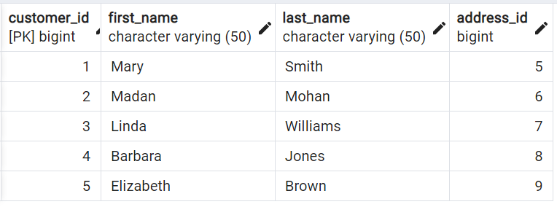
Question: How much amount was paid by customer ‘Madan’, what was mode and payment date?

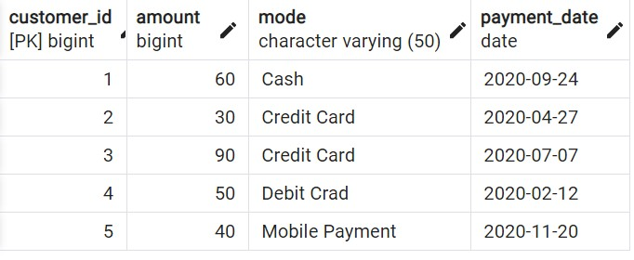
Answer: Amount = 30, Mode = Credit Card, Date = 2020-04-27

55



INNER JOIN
- LEFT JOIN

RIGHT JOIN
- FULL JOIN

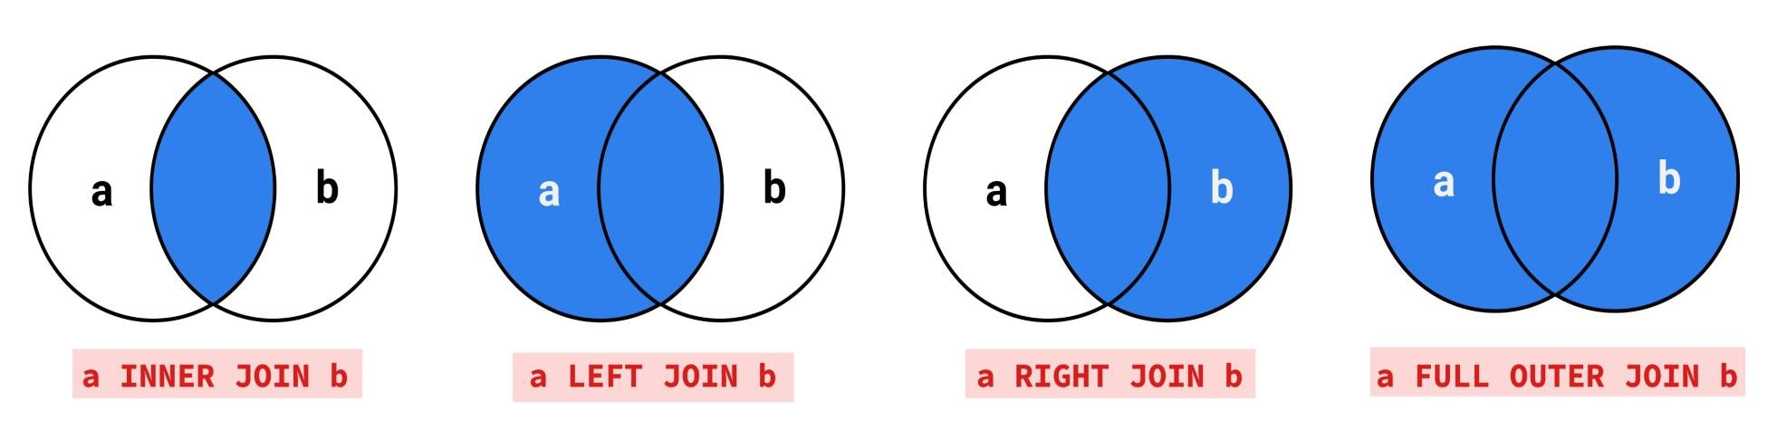

56



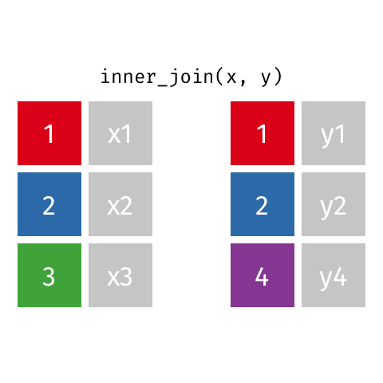
Returns records that have matching values in both tables

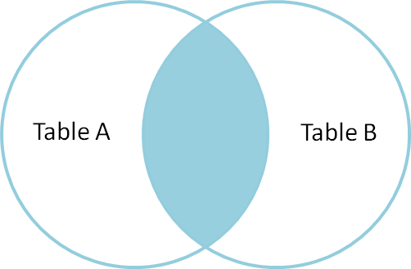

57



Syntax

SELECT column_name(s) FROM TableA

INNER JOIN TableB
ON TableA.col_name = TableB.col_name

Example
SELECT *
FROM customer AS c INNER JOIN payment AS p
ON c.customer_id = p.customer_id
58



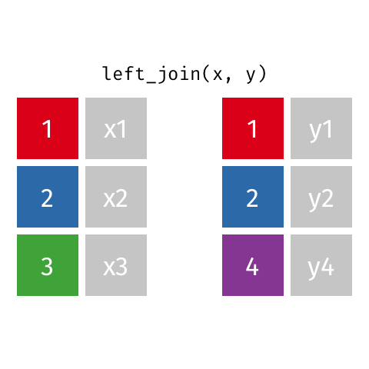
Returns all records from the left table, and the matched records from the right table

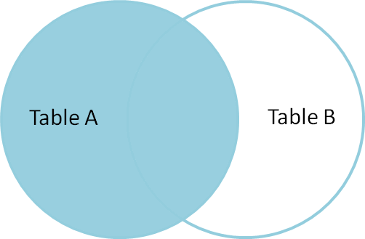

59



Syntax

SELECT column_name(s) FROM TableA

LEFT JOIN TableB
ON TableA.col_name = TableB.col_name

Example
SELECT *
FROM customer AS c LEFT JOIN payment AS p
ON c.customer_id = p.customer_id
60



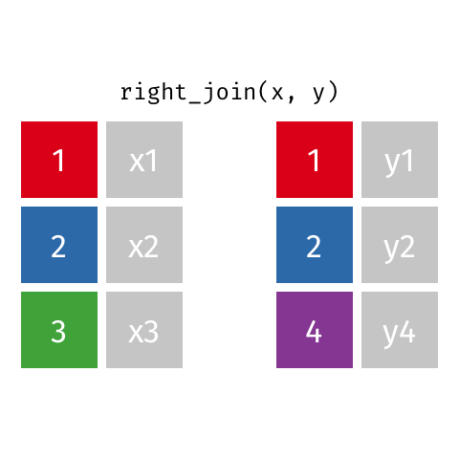
Returns all records from the right table, and the matched records from the left table

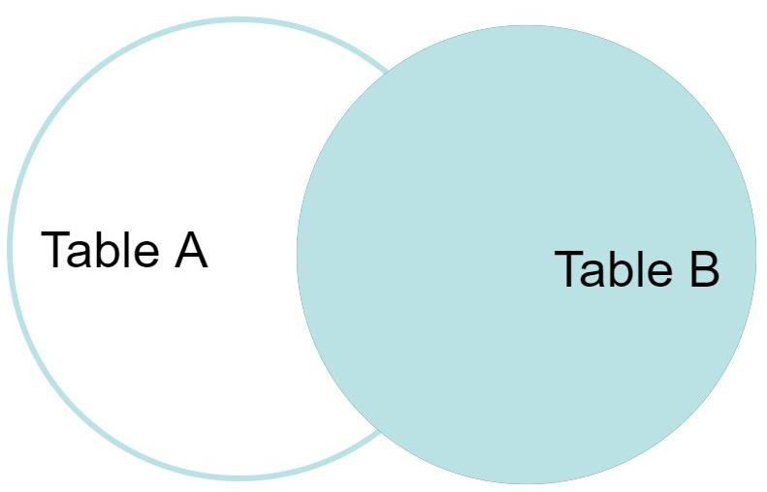

61



Syntax

SELECT column_name(s) FROM TableA

RIGHT JOIN TableB
ON TableA.col_name = TableB.col_name

Example
SELECT *
FROM customer AS c RIGHT JOIN payment AS p
ON c.customer_id = p.customer_id
62



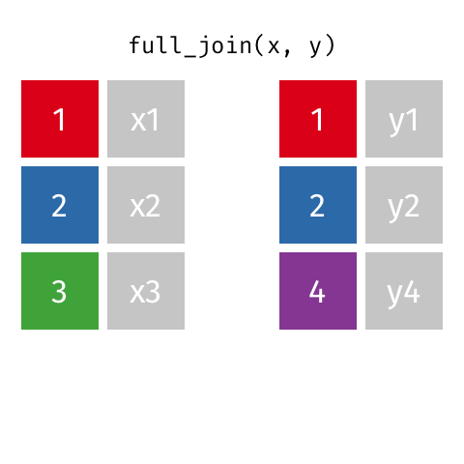
Returns all records when there is a match in either left or right table

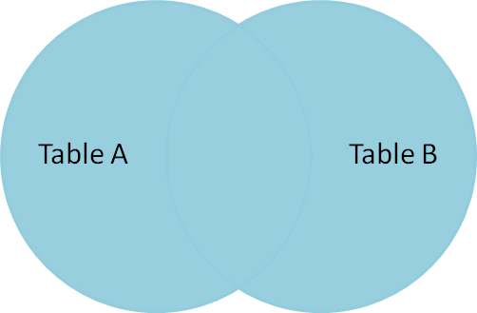

63



Syntax

SELECT column_name(s) FROM TableA

FULL OUTER JOIN TableB
ON TableA.col_name = TableB.col_name

Example
SELECT *
FROM customer AS c
FULL OUTER JOIN payment AS p ON c.customer_id = p.customer_id
64


- INNER JOIN: Returns records that have matching values in both tables
- LEFT JOIN: Returns all records from the left table, and the matched records from the right table
- RIGHT JOIN: Returns all records from the right table, and the matched records from the left table
- FULL JOIN: Returns all records when there is a match in either left or right table

65
SQL By a

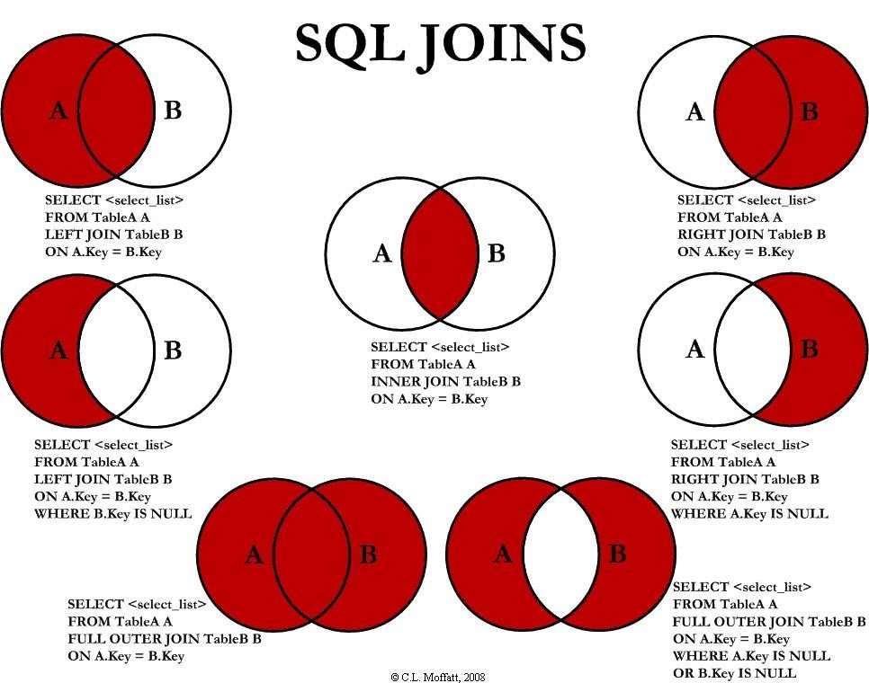

66



A self join is a regular join in which a table is joined to itself
- SELF Joins are powerful for comparing values in a column of rows with the same table

Syntax
SELECT column_name(s) FROM Table AS T1
JOIN Table AS T2
ON T1.col_name = T2.col_name
68


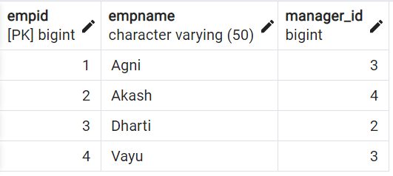
Table: emp

- Find the name of respective managers for each of the employees?

69



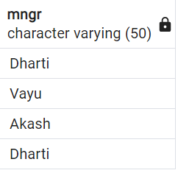

SELECT T2.empname, T1.empname
FROM emp AS T1 JOIN emp AS T2
ON T1.empid = T2.manager_id

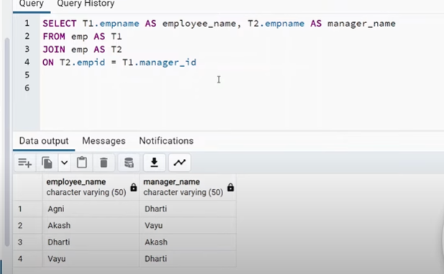

70


The SQL UNION clause/operator is used to combine/concatenate the results of two or more SELECT statements without returning any duplicate rows and keeps unique records
To use this UNION clause, each SELECT statement must have
  - The same number of columns selected and expressions
  - The same data type and
  - Have them in the same order
  - Syntax
SELECT column_name(s) FROM TableA UNION
SELECT column_name(s) FROM TableB

  - Example
SELECT cust_name, cust_amount from custA
UNION
SELECT cust_name, cust_amount from custB
71



In UNION ALL everything is same as UNION, it combines/concatenate two or more table but keeps all records, including duplicates

  - Syntax
SELECT column_name(s) FROM TableA UNION ALL
SELECT column_name(s) FROM TableB

  - Example
SELECT cust_name, cust_amount from custA
UNION ALL
SELECT cust_name, cust_amount from custB
72



Table: custA
Table: custB

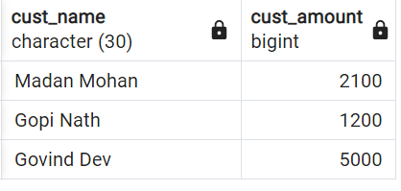
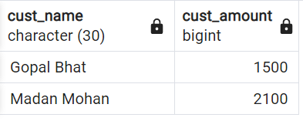

73



A Subquery or Inner query or a Nested query allows us to create complex query on the output of another query
  - Sub query syntax involves two SELECT statements
  - Syntax

SELECT column_name(s) FROM table_name
WHERE column_name operator

( SELECT column_name FROM table_name WHERE ... );

75



Question: Find the details of customers, whose payment amount is more than the average of total amount paid by all customers

Divide above question into two parts:
- Find the average amount
- Filter the customers whose amount > average amount

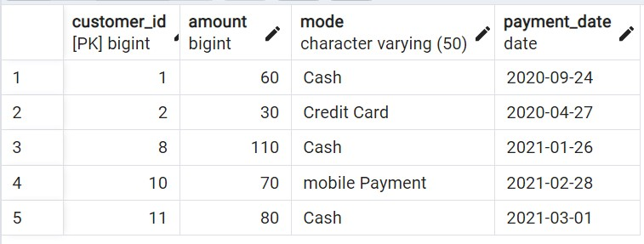

Subquery example 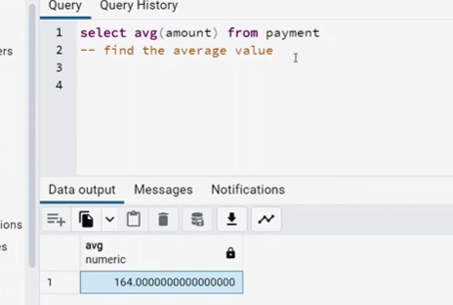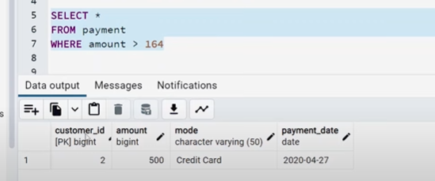
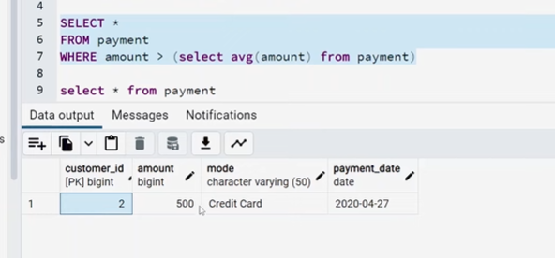
Optimistic (dynamic) 76


  - Window functions applies aggregate, ranking and analytic functions over a particular window (set of rows).
  - And OVER clause is used with window functions to define that window.
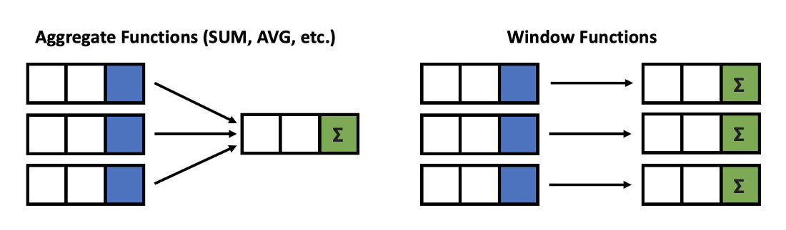
Give output one row per aggregation The rows maintain their separate identities

79

SELECT column_name(s),
( [ <PARTITION BY Clause> ] [ <ORDER BY Clause> ]
[ <ROW or RANGE Clause> ] )
FROM table_name
OVER
fun( )

Select a function
  - Aggregate functions
  - Ranking functions
  - Analytic functions

Define a Window
  - PARTITION BY
  - ORDER BY
  - ROWS

80

Let’s look at some definitions:
  - Window function applies aggregate, ranking and analytic functions over a particular window; for example, sum, avg, or row_number
  - Expression is the name of the column that we want the window function operated on. This may not be necessary depending on what window function is used
  - OVER is just to signify that this is a window function
  - PARTITION BY divides the rows into partitions so we can specify which rows to use to compute the window function
  - ORDER BY is used so that we can order the rows within each partition. This is optional and does not have to be specified
  - ROWS can be used if we want to further limit the rows within our partition. This is optional and usually not used
81

There is no official division of the SQL window functions into categories but high level we can divide into three types

Value/Analytic
- LEAD
- LAG
- FIRST_VALUE
- LAST_VALUE
Ranking
- ROW_NUMBER
- RANK
- DENSE_RANK
- PERCENT_RANK
Aggregate
- SUM
- AVG
- COUNT
- MIN
- MAX
Window Functions

82

SELECT new_id, new_cat,
AGGREGATE FUNCTION
Example
SUM(new_id) OVER( PARTITION BY new_cat ORDER BY new_id ) AS "Total", AVG(new_id) OVER( PARTITION BY new_cat ORDER BY new_id ) AS "Average", COUNT(new_id) OVER( PARTITION BY new_cat ORDER BY new_id ) AS "Count", MIN(new_id) OVER( PARTITION BY new_cat ORDER BY new_id ) AS "Min", MAX(new_id) OVER( PARTITION BY new_cat ORDER BY new_id ) AS "Max" FROM test_data

new_id | new_cat | Total | Average | Count | Min | Max
100 | Agni | 300 | 150 | 2 | 100 | 200
200 | Agni | 300 | 150 | 2 | 100 | 200
500 | Dharti | 1200 | 600 | 2 | 500 | 700
700 | Dharti | 1200 | 600 | 2 | 500 | 700
200 | Vayu | 1000 | 333.33333 | 3 | 200 | 500
300 | Vayu | 1000 | 333.33333 | 3 | 200 | 500
500 | Vayu | 1000 | 333.33333 | 3 | 200 | 500

83

SELECT new_id, new_cat,
SUM(new_id) OVER( ORDER BY new_id ROWS BETWEEN UNBOUNDED PRECEDING AND UNBOUNDED FOLLOWING) AS "Total", AVG(new_id) OVER( ORDER BY new_id ROWS BETWEEN UNBOUNDED PRECEDING AND UNBOUNDED FOLLOWING) AS "Average", COUNT(new_id) OVER( ORDER BY new_id ROWS BETWEEN UNBOUNDED PRECEDING AND UNBOUNDED FOLLOWING) AS "Count", MIN(new_id) OVER( ORDER BY new_id ROWS BETWEEN UNBOUNDED PRECEDING AND UNBOUNDED FOLLOWING) AS "Min", MAX(new_id) OVER( ORDER BY new_id ROWS BETWEEN UNBOUNDED PRECEDING AND UNBOUNDED FOLLOWING) AS "Max"
FROM test_data
AGGREGATE FUNCTION
Example
new_id | new_cat | Total | Average | Count | Min | Max
100 | Agni | 2500 | 357.14286 | 7 | 100 | 700
200 | Agni | 2500 | 357.14286 | 7 | 100 | 700
200 | Vayu | 2500 | 357.14286 | 7 | 100 | 700
300 | Vayu | 2500 | 357.14286 | 7 | 100 | 700
500 | Vayu | 2500 | 357.14286 | 7 | 100 | 700
500 | Dharti | 2500 | 357.14286 | 7 | 100 | 700
700 | Dharti | 2500 | 357.14286 | 7 | 100 | 700

84
NOTE: Above we have used: “ROWS BETWEEN UNBOUNDED PRECEDING AND UNBOUNDED FOLLOWING”
which will give a SINGLE output based on all INPUT Va_{S}lu_{QL}e_{B}s_{y}/P_{R}A_{ish}R_{a}T_{b}I_{h}T_{M}IO_{is}N_{hra}(if used)

SELECT new_id,
RANKING FUNCTION
Example
ROW_NUMBER() OVER(ORDER BY new_id) AS "ROW_NUMBER",
RANK() OVER(ORDER BY new_id) AS "RANK",
DENSE_RANK() OVER(ORDER BY new_id) AS "DENSE_RANK", PERCENT_RANK() OVER(ORDER BY new_id) AS "PERCENT_RANK"
FROM test_data

new_id | ROW_NUMBER | RANK | DENSE_RANK | PERCENT_RANK
100 | 1 | 1 | 1 | 0
200 | 2 | 2 | 2 | 0.166
200 | 3 | 2 | 2 | 0.166
300 | 4 | 4 | 3 | 0.5
500 | 5 | 5 | 4 | 0.666
500 | 6 | 5 | 4 | 0.666
700 | 7 | 7 | 5 | 1
85

SELECT new_id,
ANALYTIC FUNCTION
Example
FIRST_VALUE(new_id) OVER( ORDER BY new_id) AS "FIRST_VALUE", LAST_VALUE(new_id) OVER( ORDER BY new_id) AS "LAST_VALUE", LEAD(new_id) OVER( ORDER BY new_id) AS "LEAD",---it will escape first leading value
LAG(new_id) OVER( ORDER BY new_id) AS "LAG"—it will escape last value
FROM test_data
new_id | FIRST_VALUE | LAST_VALUE | LEAD | LAG
100 | 100 | 100 | 200 | null
200 | 100 | 200 | 200 | 100
200 | 100 | 200 | 300 | 200
300 | 100 | 300 | 500 | 200
500 | 100 | 500 | 500 | 300
500 | 100 | 500 | 700 | 500
700 | 100 | 700 | null | 500
NOTE: If you just want the single last value from whole column, use: “ROWS BETWEEN
UNBOUNDED PRECEDING AND UNBOUNDED FOLLOWING”

86

Offset the LEAD and LAG values by 2 in the output columns ?

INPUT
OUTPUT
new_id
100
200
200
300
500
500
700

new_id | LEAD | LAG
100 | 200 | NULL
200 | 300 | NULL
200 | 500 | 100
300 | 500 | 200
500 | 700 | 200
500 | NULL | 300
700 | NULL | 500

87

SELECT new_id,
ANALYTIC FUNCTION
Assignment
LEAD(new_id, 2) OVER( ORDER BY new_id) AS "LEAD_by2", LAG(new_id, 2) OVER( ORDER BY new_id) AS "LAG_by2" FROM test_data

new_id | LEAD_by2 | LAG_by2
100 | 200 | null
200 | 300 | null
200 | 500 | 100
300 | 500 | 200
500 | 700 | 200
500 | null | 300
700 | null | 500

88



The CASE expression goes through conditions and returns a value when the first condition is met (like if-then-else statement). If no conditions are true, it returns the value in the ELSE clause.

  - If there is no ELSE part and no conditions are true, it returns NULL.

Also called CASE STATEMENT

90



    - Example:
- General CASE Syntax
CASE
WHEN condition1 THEN result1 WHEN condition2 THEN result2 WHEN conditionN THEN resultN ELSE other_result
END;

SELECT customer_id, amount, CASE
WHEN amount > 100 THEN 'Expensive product' WHEN amount = 100 THEN 'Moderate product' ELSE 'Inexpensive product'
END AS ProductStatus FROM payment

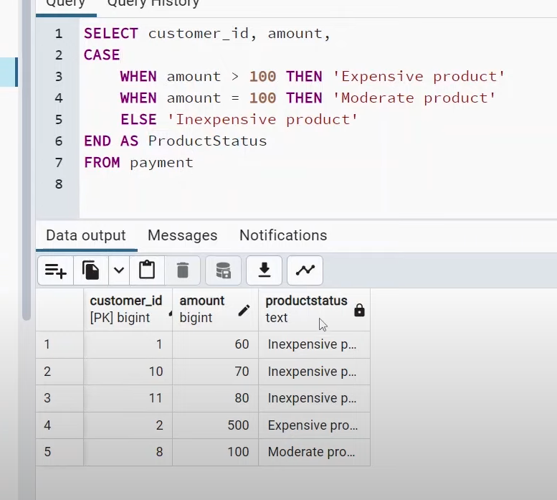

92



      - Example:
- CASE Expression Syntax
CASE Expression
WHEN value1 THEN result1 WHEN value2 THEN result2 WHEN valueN THEN resultN ELSE other_result
END;
SELECT customer_id,
CASE amount
WHEN 500 THEN 'Prime Customer' WHEN 100 THEN 'Plus Customer' ELSE 'Regular Customer'
END AS CustomerStatus FROM payment

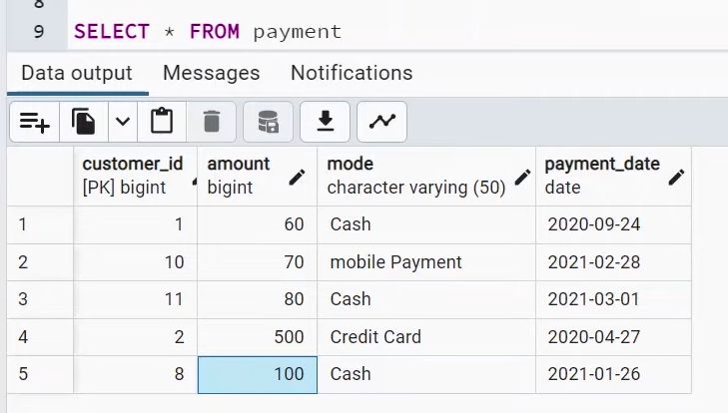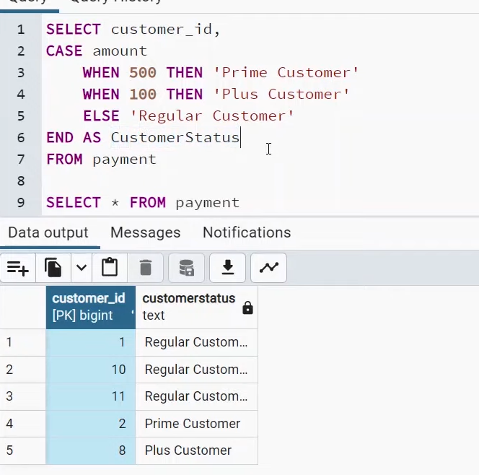

93

A common table expression, or CTE, is a temporary named result set created from a simple SELECT statement that can be used in a subsequent SELECT statement
  - We can define CTEs by adding a WITH clause directly before SELECT, INSERT, UPDATE, DELETE, or MERGE statement.

The WITH clause can include one or more CTEs separated by commas

(CTE is just like a function in programming language)

CTE query

The name of this CTE is my_cte, and the CTE query is SELECT a,b,c FROM Table1. The CTE starts with the WITH keyword, after which you specify the name of your CTE, then the content of the query in parentheses. The main query comes after the closing parenthesis and refers to the CTE. Here, the main query (also known as the outer query) is SELECT a,c FROM my_cte
- Syntax
WITH my_cte AS (
SELECT a,b,c
FROM Table1 )
SELECT a,c
FROM my_cte
Main query
97

1. Example EASY
WITH my_cte AS (
SELECT *, AVG(amount) OVER(ORDER BY
p.customer_id) AS "Average_Price",
COUNT(address_id) OVER(ORDER BY c.customer_id) AS "Count"
FROM payment as p
INNER JOIN customer AS c
ON p.customer_id = c.customer_id
)
SELECT first_name, last_name FROM my_cte

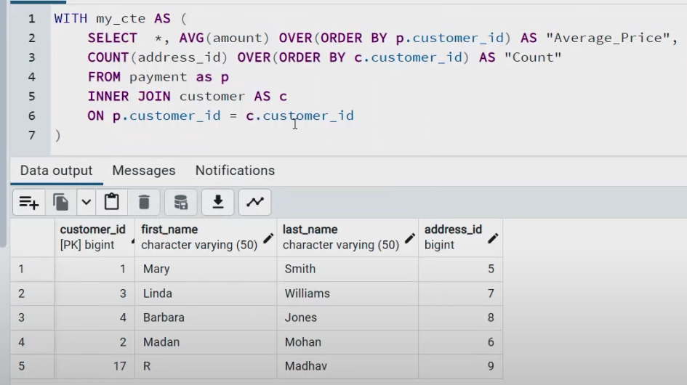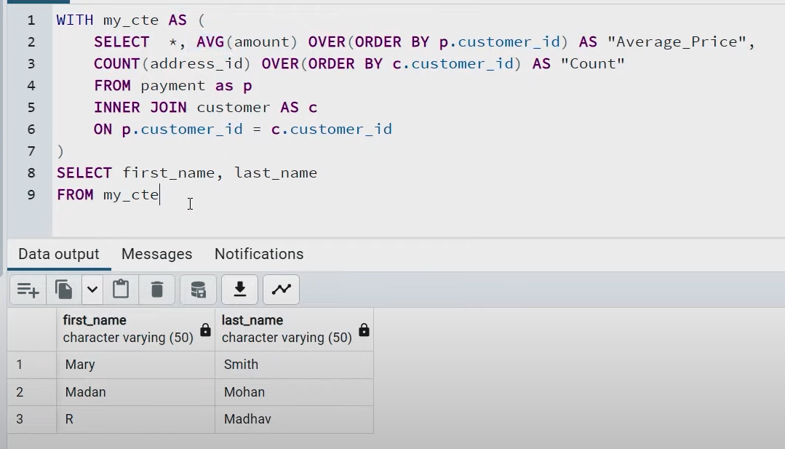

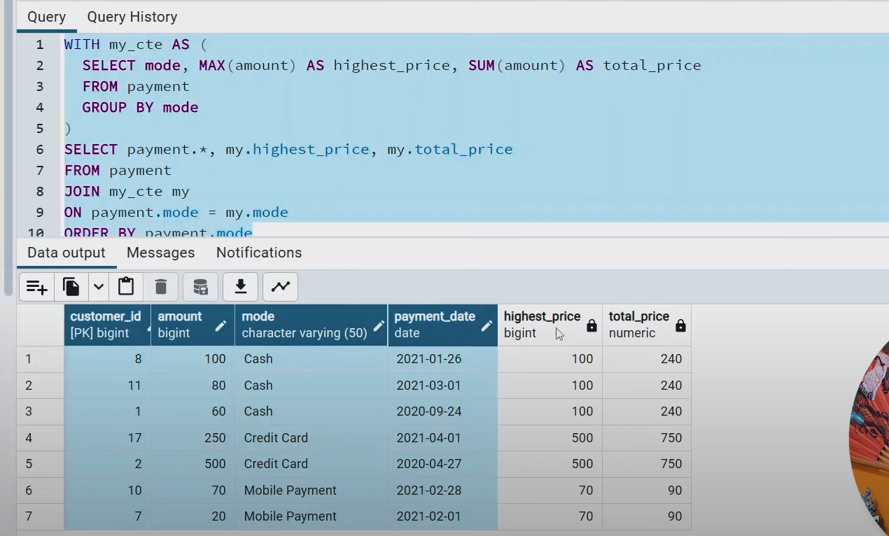
2. Example Advance

WITH my_cte AS (
SELECT mode, MAX(amount) AS highest_price, SUM(amount) AS total_price
FROM payment GROUP BY mode
)
SELECT payment.*, my.highest_price, my.total_price
FROM payment JOIN my_cte my
ON payment.mode = my.mode ORDER BY payment.mode
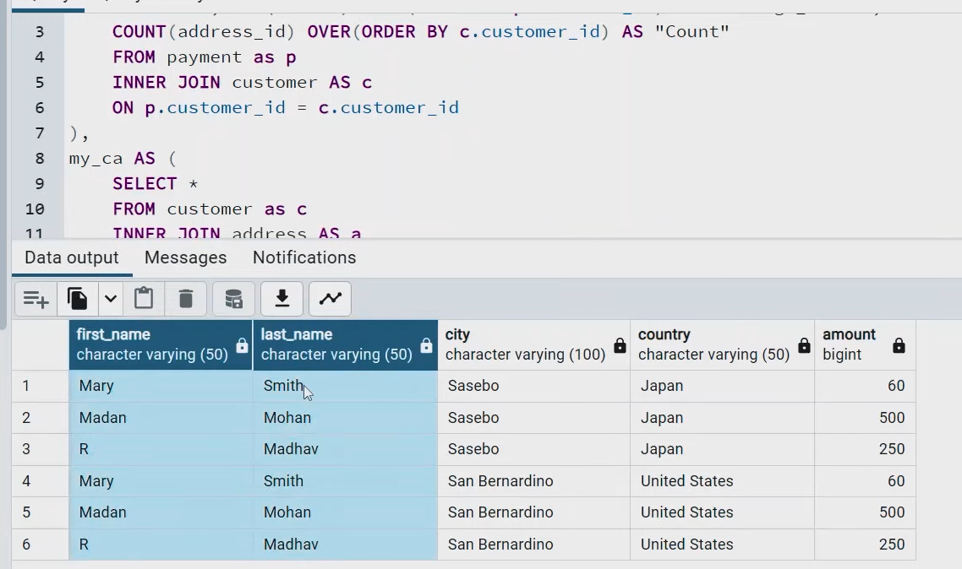F
1. Example Multiple CTEs
WITH my_cp AS (
SELECT *, AVG(amount) OVER(ORDER BY p.customer_id) AS "Average_Price",
COUNT(address_id) OVER(ORDER BY c.customer_id) AS
"Count"
FROM payment as p INNER JOIN customer AS c
ON p.customer_id = c.customer_id
),
my_ca AS (
SELECT *
FROM customer as c INNER JOIN address AS a
ON a.address_id = c.address_id INNER JOIN country as cc
ON cc.city_id = a.city_id
)
SELECT cp.first_name, cp.last_name, ca.city, ca.country, cp.amount FROM my_ca as ca , my_cp as cp
Recursive CTE
A recursive cte references itself , it return the results subset ,then it repeatedly(recursively) references itself ,and stops when it returns all the results.
A recursive cte has three elements
Non recursive term
Recursive term
Termination check
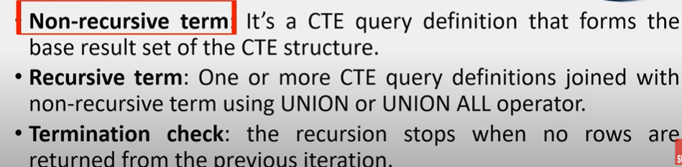
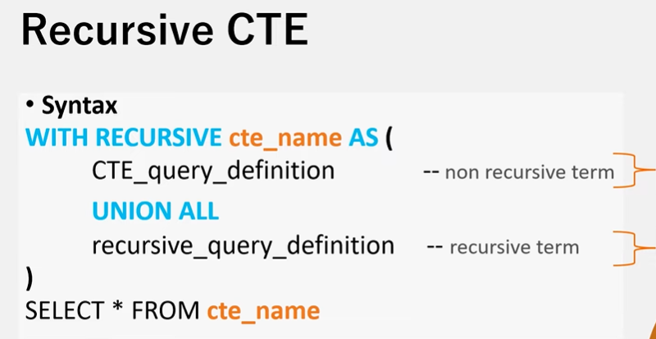
Recursive query
Base query

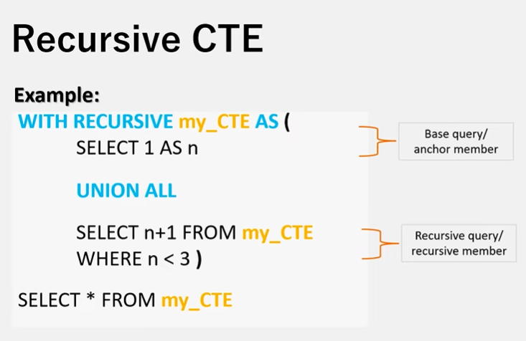

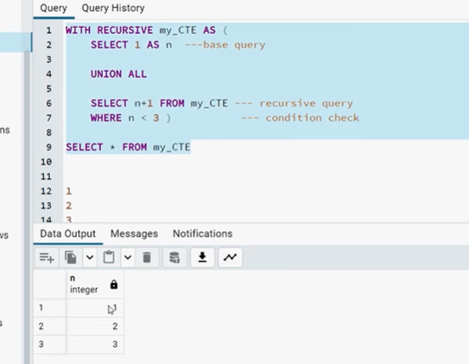

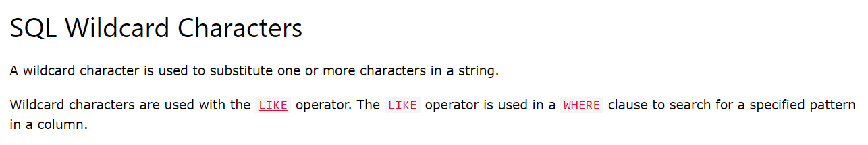
1.The % wildcard represents any number of characters, even zero characters.
2.The _ wildcard represents a single character.
It can be any character or number, but each _ represents one, and only one, character
SELECT * FROM Customers
WHERE City LIKE '_ondon';

